VENTURA RUSSELL
DIVERSIFIED 90 MODEL
May 2024
VENTURA
DIVERSIFIED 50 FUND
June 2022

About VMAPS
Ventura Investment Management Ltd (Ventura) has been proudly managing the asset of Australian investors for over 10 years. Our mission is to assist all Australians in establishing and maintaining financial independence that will allow our investors to achieve what is most important to them.

Ventura Managed Account Portfolios (VMAPS) is a next generation portfolio management solution that can be tailored to individual investor circumstances and goals. Through our scale and experience, our investors gain access to the thoughts and expertise of the world’s leading asset managers.

About Russell
With core capabilities extending across capital markets, manager research, portfolio construction, and portfolio implementation; based in the US, Russell is a global asset manager with more than
$333bn in assets under management.

Russell believe smart decisions are grounded in timely research and insights, so they inspect and analyse key factors affecting investor outcomes and seek to create and adjust strategies to help achieve them. Of course, diversification and multi-asset investing do not assure a profit or protect against loss.
To create multi-asset solutions, Russell draw from capabilities created and integrated in response to investors’ needs. They are one of only a few firms that offer capital markets insights, manager research, portfolio construction, and portfolio implementation. Russell research markets globally, and research managers, seeking to identify leading performers. They have decades of experience successfully building and managing portfolios, with their implementation efficiency anchored by a robust trading desk. Their precise views of market segments
and performance are enhanced by their experience in building equity indexes. When it comes to our multi-asset solutions, all these
capabilities are brought to bear on behalf of our clients. And they’re all aimed precisely at helping these clients reach their outcomes.

Investment Objective
To provide returns over the medium term, with moderate volatility, consistent with a diversified mix of defensive and growth oriented assets.

Recommended Investment Timeframe
4 years

Investment Strategy
The Fund typically invests in a diversified portfolio mix with exposure to growth investments around 50% and defensive investments around 50%. Derivatives may be used to implement investment strategies.

Fund Summary

Units | APIR code | Management fee | Indirect Cost Ratio
Class A | VEN0028AU | 0.00% | 0.80%pa

Investment Performance - Class A _{31/05/2024}

Period | Income % | Growth % | Return %
1 month | 0.0 | 1.3 | 1.3
3 months | 0.5 | 1.0 | 1.4
6 months | 0.7 | 9.1 | 9.7
1 yr pa | 4.3 | 7.9 | 12.2
3 yr pa | 8.1 | -3.4 | 4.8
5 yr pa | 7.8 | -0.9 | 6.9
7 yr pa | 7.9 | -1.3 | 6.6

This Class Units for have been operating since 31 March 2016. To provide a longer term view of
this Fund’s performance we have shown returns from the underlying fund manager which has been managed on the same basis.

Asset Allocation as at 31/05/2024

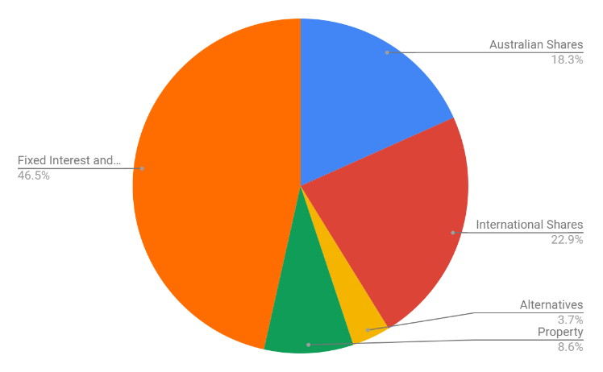

For more information speak to your financial adviser. 1300 738 421
info@venturafm.com.au venturafm.com.au

This document has been prepared and issued by Ventura Investment Management Limited, ABN 49 092 375 258, AFS licence number 253045 (Ventura). Information contained in this document is of a general nature only, it is not intended as advice as it does not take into account your individual objectives, financial situation or needs. You should consider the Product Disclosure Statement (PDS) in deciding to acquire or continue to hold this product. Investment can only be made by completing an application form with your
financial adviser. To obtain a copy of the PDS for the fund contact your adviser or Ventura. Past performance is not necessarily indicative of future performance.

